**Regular Expression & Non-Determenistic Finite Automata**

**1)Regular expression of constant => /[0-9]+/**

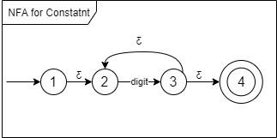

**2)Regular expression for identifier=>/[a-zA-Z_]+[0-9]+[a-zA-Z_0-9]*/** 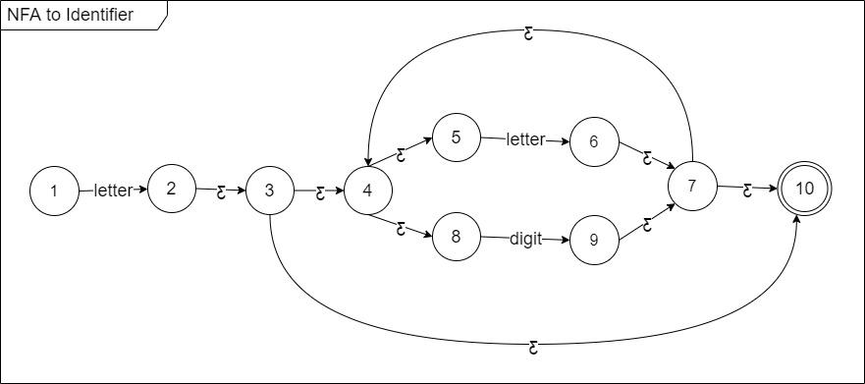

**3)Regular expression for relational operators =>/((<|>) =?)|(!|=)=/**

**4)Regular expression for comment => /(/(-|#))|(#/)/**

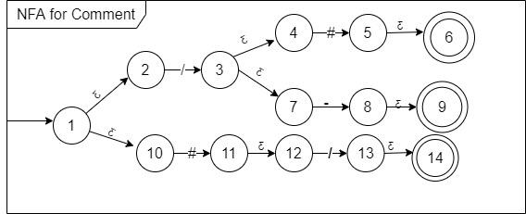

**Determenistic Finite Automata**



